​

*Information Technology Institute*

*Power BI Developer Track*

**Examination System**

Supervisor:

Eng. **Nadia saleh**

**Presented by:**

Eslam Ibrahim Badr

Abedelmonem Ali Elmongy   
Rawan Emad Elghali  
Yomna Hamed Shehabeldien  
MeenatuAllah Mohammed Bahaa

## 

## **ABSTRACT**

This Examination System documentation provides a comprehensive guide and reference for understanding and utilizing the system.

It aims to assist administrators, academic advisors, and other stakeholders involved in the evaluation and analysis of student and instructors performance. The document covers various aspects of the examination system, including its purpose, functionality, and usage. The Examination System Documentation includes sections the explain every part of the software,Furthermore, the documentation provides insights into the evaluation process, guiding professors on how to assess student answers, assign grades, and provide feedback.

It also explores the analysis capabilities of the system, allowing stakeholders to track and analyze student performance trends, identify areas of improvement, and generate comprehensive reports.

So that any stakeholder can use it to analyze its student, instructors, departments, courses and exam data and use the drived insights from it in improving the process of his educational institution.

## **INTRODUCTION**

Welcome to the Examination System of ITI ..

Due our journey as being itian’s students in power BI Track,

we have been inspired actually to develop this examination system in   
a helpful manner,That covers different aspects of this huge educational institution so that any supervisor or manger can use it to analysis

the data of the students instructors, departments, courses and exam performance and KPIs and job offers and progress through different dashboards for each of them which will help to give a useful insights to be used.

Once exams are administered, the evaluation phase becomes crucial. Professors will find detailed instructions on how to assess student answers, assign grades, and provide valuable feedback.

As after taking the data of the students and their grades of the courses this gonna help to know their progress in the study process and will help in the end to know the performance of them and try to improve it so they can achieve the kpis in an excellent way and get a good job

So we in our system explore methods for tracking and analyzing performance trends, identifying areas of improvement, and generating comprehensive reports. These insights empower educators to make data-driven decisions and implement targeted interventions to enhance learning outcomes.

Lets start our dive into the software ..

## **Software Development life cycle**

In this section we are clarification the life cycle we have been through to develop the system:  
**The life cycle:**

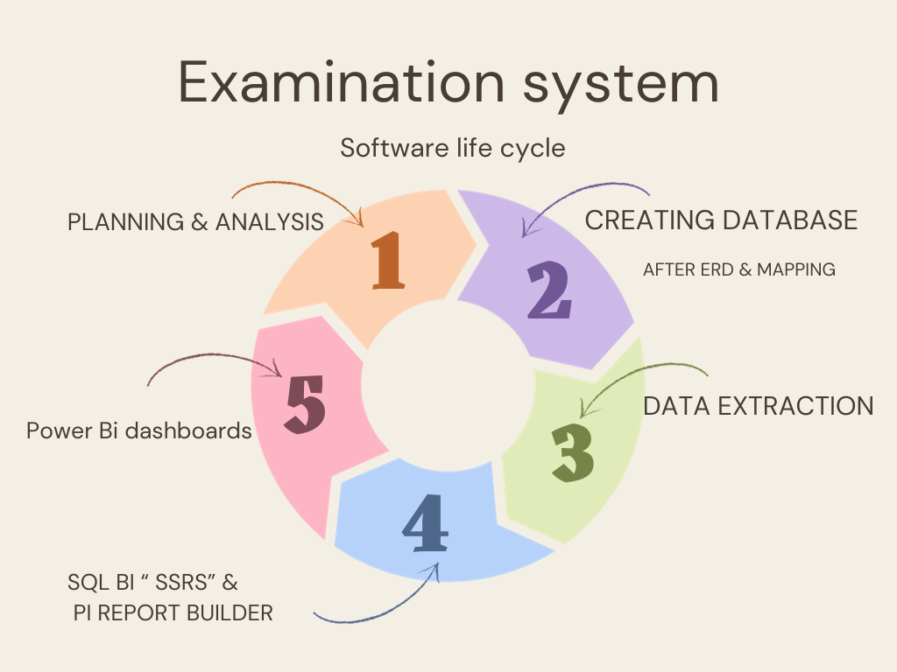

**Planning & Analysis:**In this phase we started to plan for the software by analysis the main idea of  
 system and see what is the important features that the user will need , we did this by exploring how others system are applied and its user experience and the persona need.

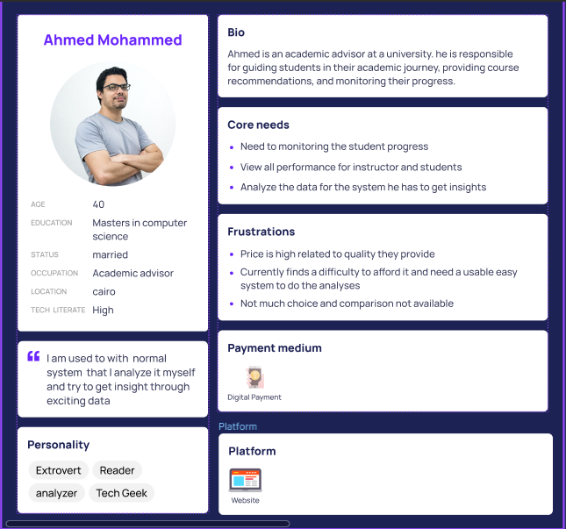

User persona :

**ERD & Mapping:**

at this phase we decided our entities and the tables which are :  
{ Student ,Department ,Instructor,Course,Topic,Question,Exam ,Choice ,

Exam_Question ,student course student answer, student exam grade,

Course evaluation,KPI ,Job offer }  
we made the mapping for it after creating it as the below :

ERD:

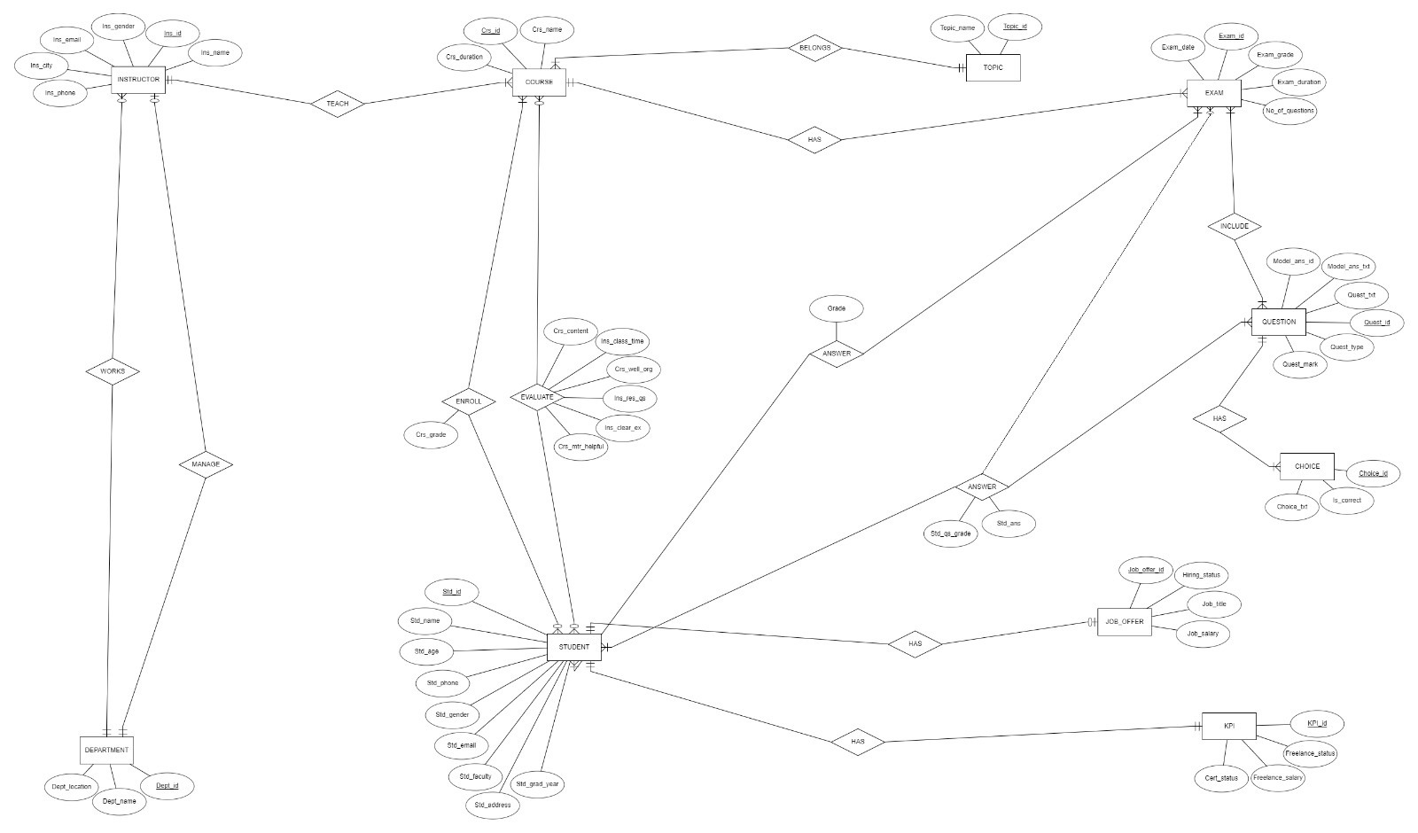

**Mapping:**

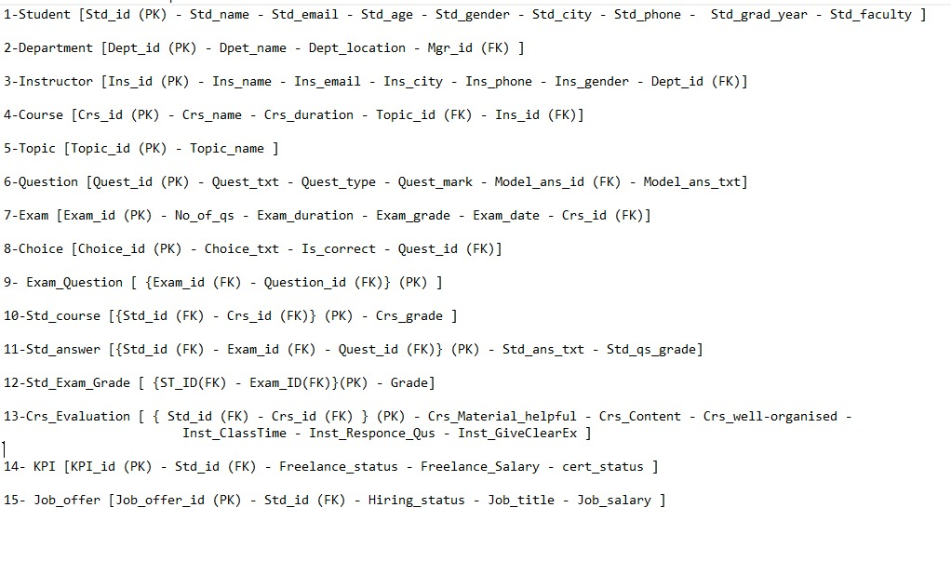

**Creating Database & Implementation :**

Creating a database for an examination system typically involves defining tables :  
{Student ,Department ,Instructor,Course,Topic,Question,Exam ,Choice ,

Exam_Question ,student course student answer, student exam grade,

Course evaluation,KPI ,Job offer }  
Import data directly from Excel files by using the SQL Server Import and Export Wizard.  
  
Creation :

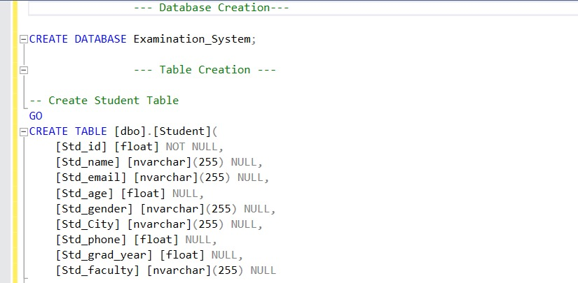

**2:**

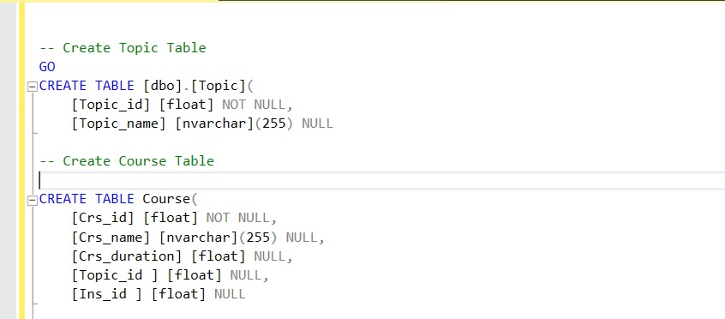

**3:**

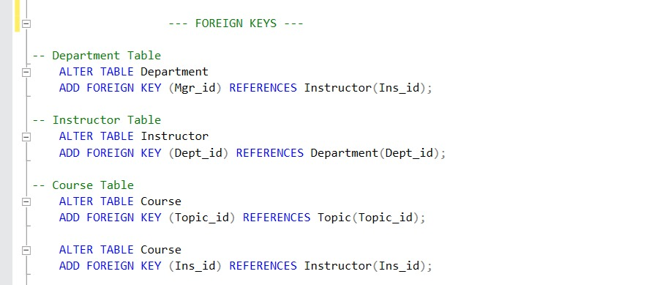

**4: storde prodeduer for table :**

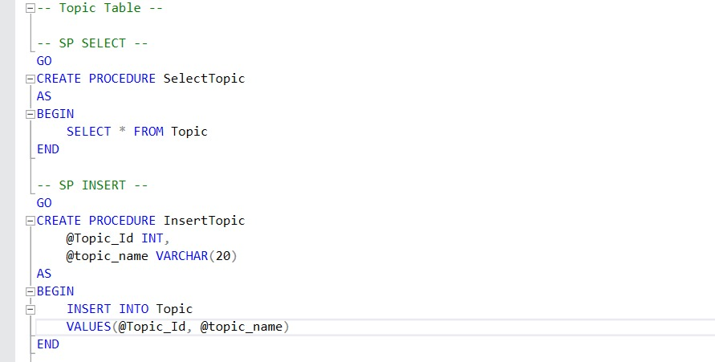

**sp for table :**

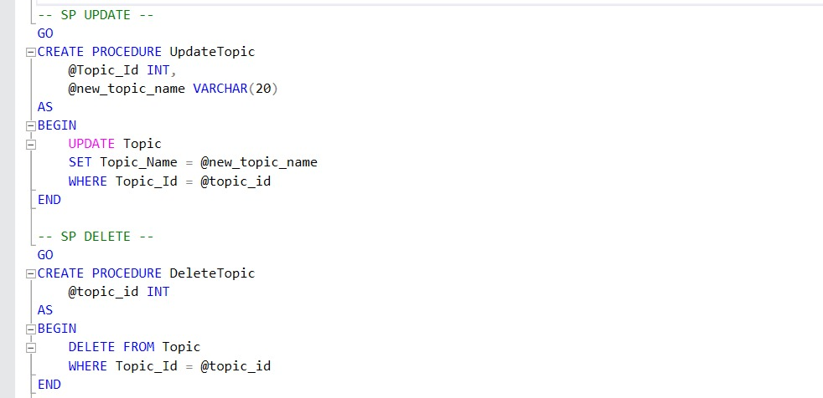

**Generating exam SP :**

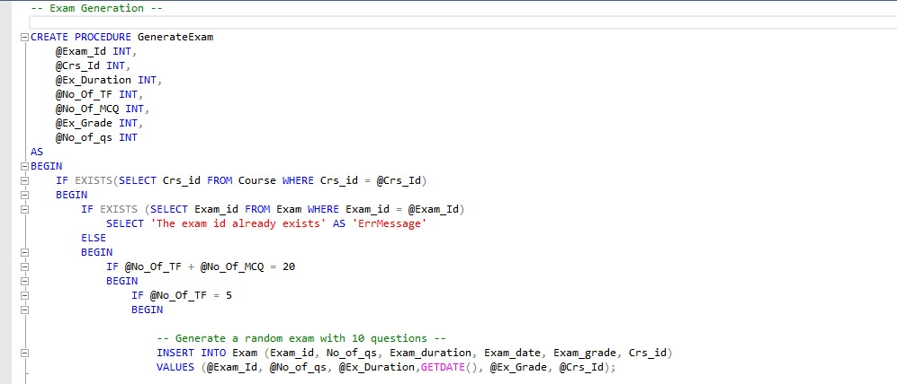

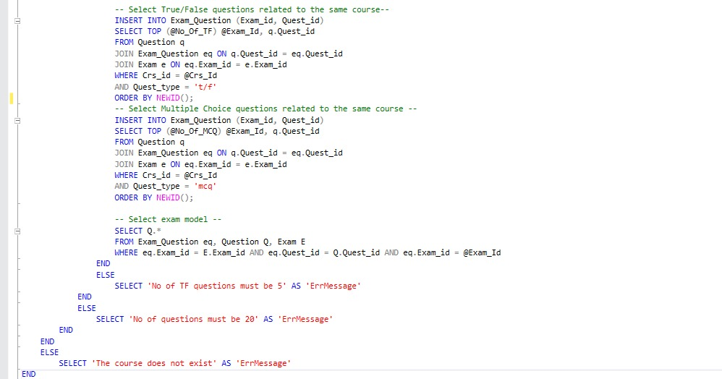

**SP Exam Answer:**

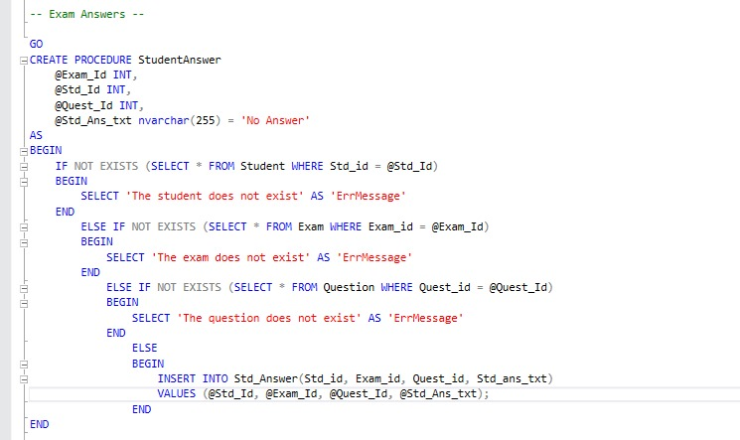

**SP Exam Correction :**

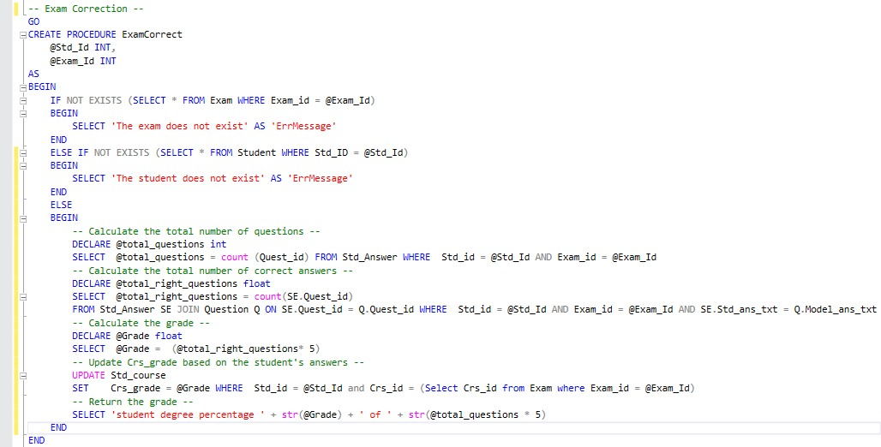

**After fishing the storde procedures and testing them we moved to the phase of :**

**Data extraction:**   
At this phase we have extracted data from a database for generating reports in Power BI Desktop, SQL Server Report Service, Power BI Report Builder that need querying database, saving the data as a CSV file, then importing it into the reporting tool

**SSRS:** SQL Serverreport server to present the data from stored procedures to SSRS   
as the upcoming :  
-1-Report that returns the students information according to Department No parameter

.

-2-Report that takes the student ID and returns the grades of the student in all courses.

-3-Report that takes the instructor ID and returns the name of the courses that he teaches and the number of student per course.

-4-Report that takes course ID and returns its topics

-5-Report that takes exam number and returns the Questions in it and choices [free-form report]

-6-Report that takes exam number and the student ID then returns the Questions in this exam with the student answers.

**Power BI Report builder:**   
paginated report designed for creating a report has the information of students, instructor,exams like following:

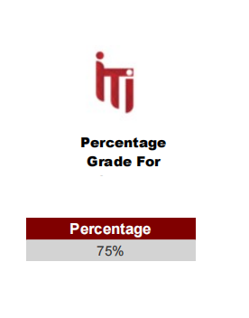

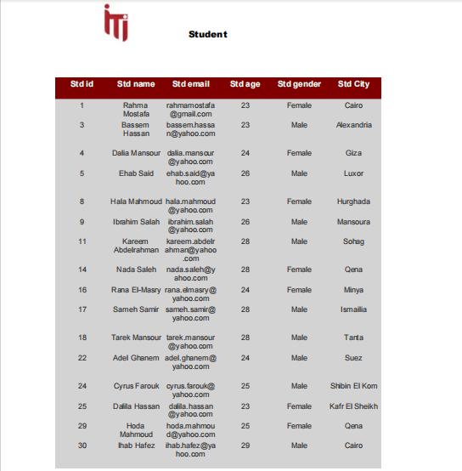

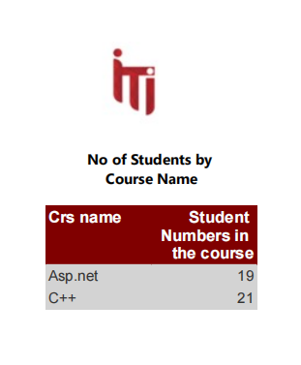

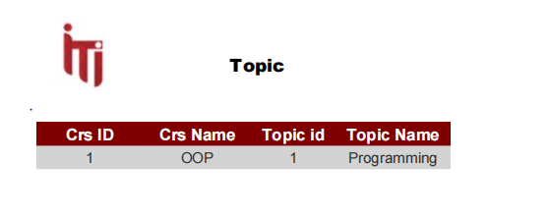

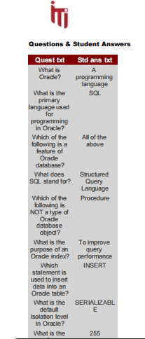

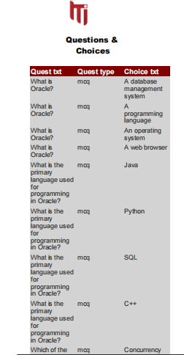

**Power BI Dashboard:**

After the above phases up we came to the time of making the Dashboards that   
supervisor or the manager or any stake holder will use it to analyze the needed data from any table we mentioned in our system to get the important insights that will be so useful in tracking the performance of the system overall   
we have made 20 dashboards but we will focus now on the main 6 overview in the upcoming screens :

First over view when you log into the system dashboard:

Here we can see the 5 main sections for the system that can the user navigate through it to get his needed information and insights contains student , instructor , department, course, exam:  
  
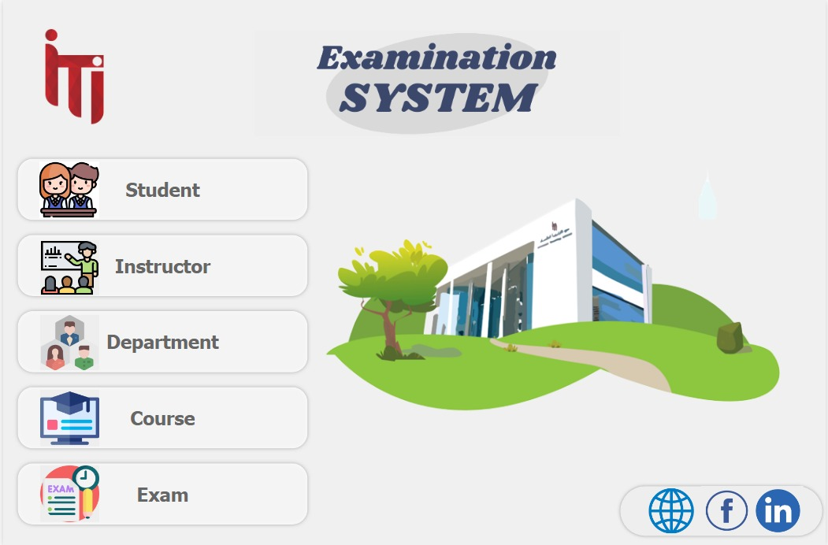

1. Student overview :

Here we can see the total number of the students and number due to the gender distribution and the average age , also you can find student by age and student graduation year , and we should mention that we made filter so that you can enter any name for the student and get the needed insight due to the student you wrote his name and there is important navigation buttons in the left side to choose from it thing you need to know from distribution or the KPIs or the job offers or graduated students to get the insights you want

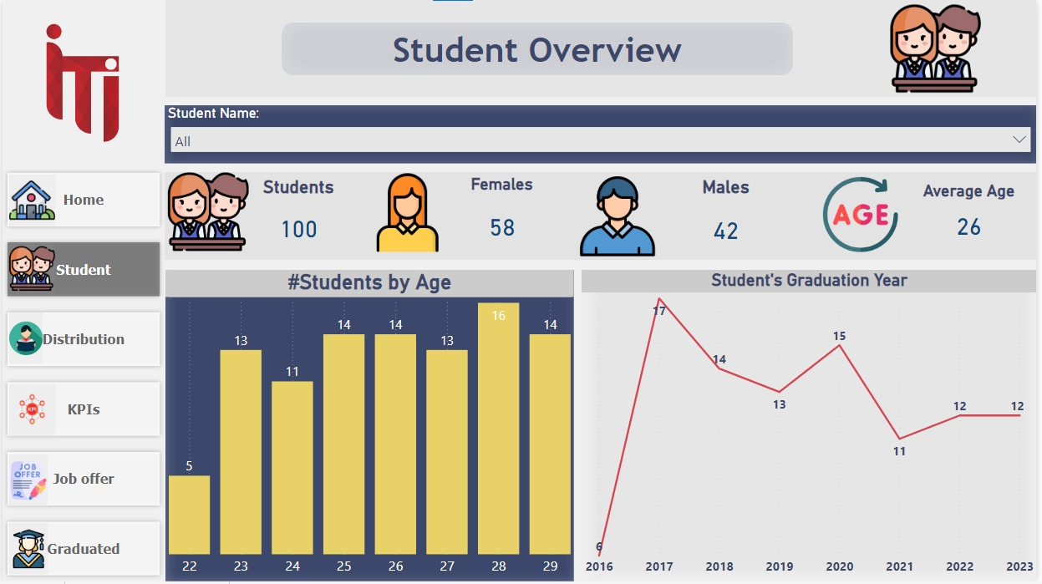

1. Instructor overview :

Here we can see there is 2 main filters one by the instructor city and the other by the instructor name to filter the data due this two mentioned then   
when you choose the instructor name you can have its mail , also we made a card to the total number of instructors we have, and number of instructors in each department in the system and also we got map to get the number of the instructor in each city and the distribution of the instructors by its gender  
also you can find in the left related navigation button for the instructors to choose from and they are : feedback or the instructor performance

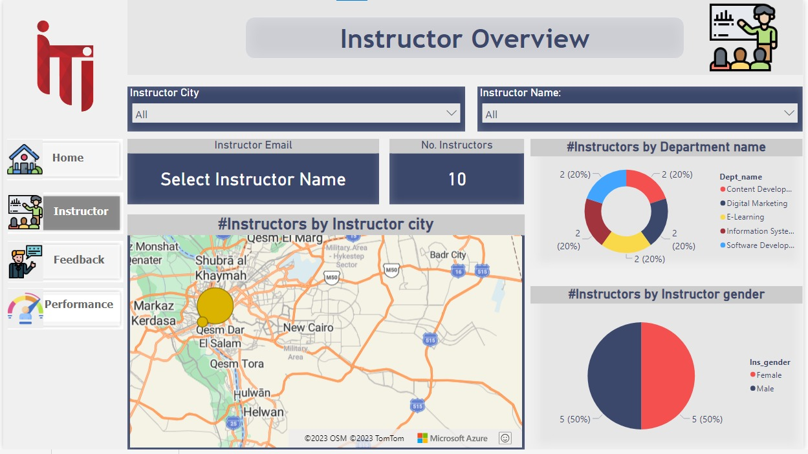

4-Department overview :

Here we can see there is main filters on the dashboard here and it is the department name , and when you choose the name the manger of it will show immediately , we made a card to show the total number of the departments we have , and distribution and total number for the instructor in each department and numbers of the departments by its location   
and as usual there in the left you can find 2 navigate buttons to choose from department or department performance

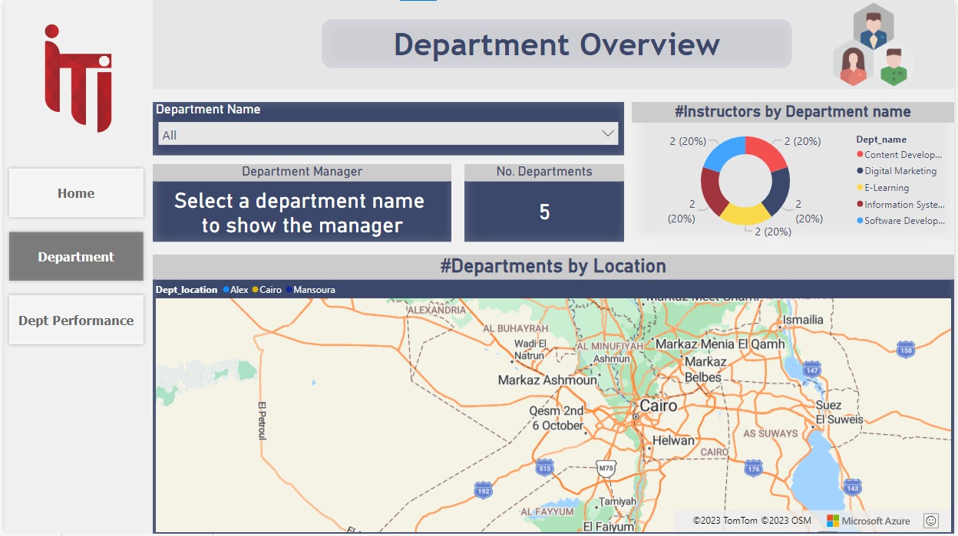

1. Course overview :

Here we can see there is main filters on the dashboard here and it is the course name , and when you choose the name it will show immediately the insights due to it , we made a card to show the total number of the courses and average courses duration , also we have the course duration due to the topic name and the number of courses by department name , also we have table to show information like the course name and its duration and topic name and number of students , and as usual there in the left you can find navigation buttons to choose from course , course grade course feedback and student course

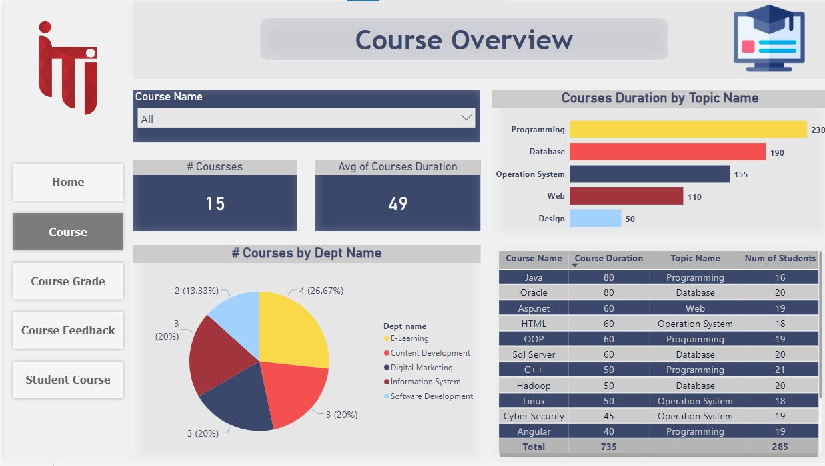

1. Exam overview :

Here we can see there is main filters on the dashboard here and it is the course name , and when you choose the name it will show immediately the insights due to it the total Exams number and number of total questions and exam duration , and also we have the number of exams by the month and number of questions by the question type and a table show information about the exam date and its day and number of exams and its id

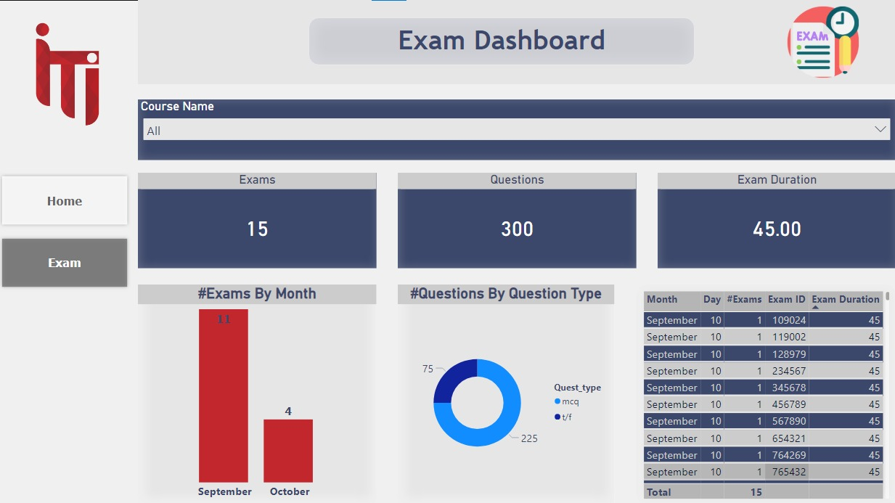

By all of those dashboards you can navigate through the system and get the main insight you want and do the analysis in an easy way to help you in improving your progress in the educational institution and the progress of the student and we can sum this up in the   
journey map of the user in the up coming visual :

